**AWS PROJECT**

**Screenshots of Dashboards**

1. **AWS Login screen with username**

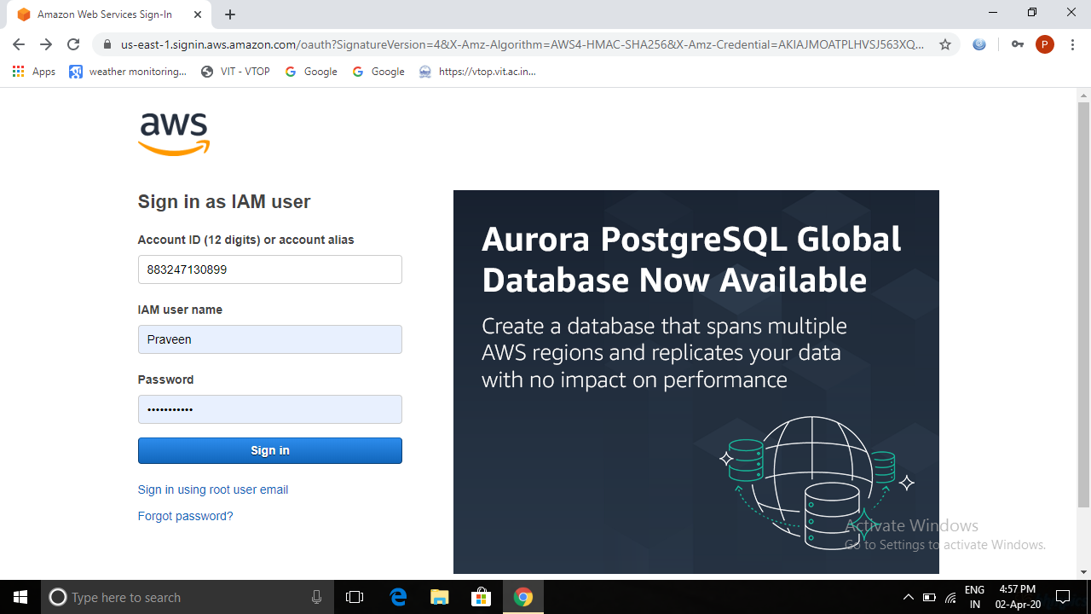

1. **EC2 Dashboard**

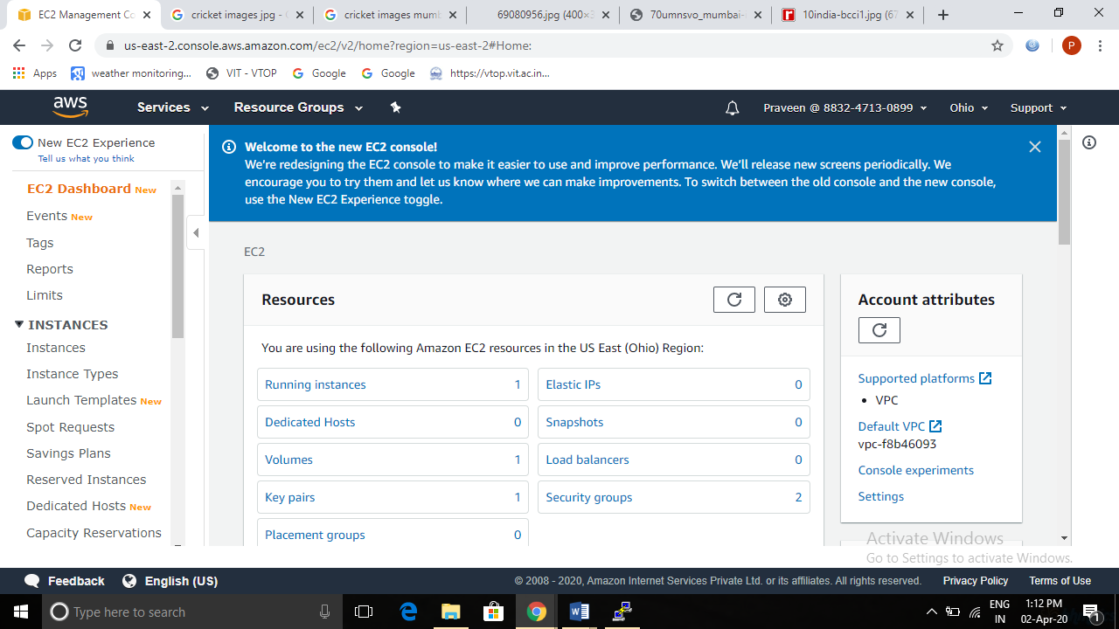

1. **S3 Dashboard**

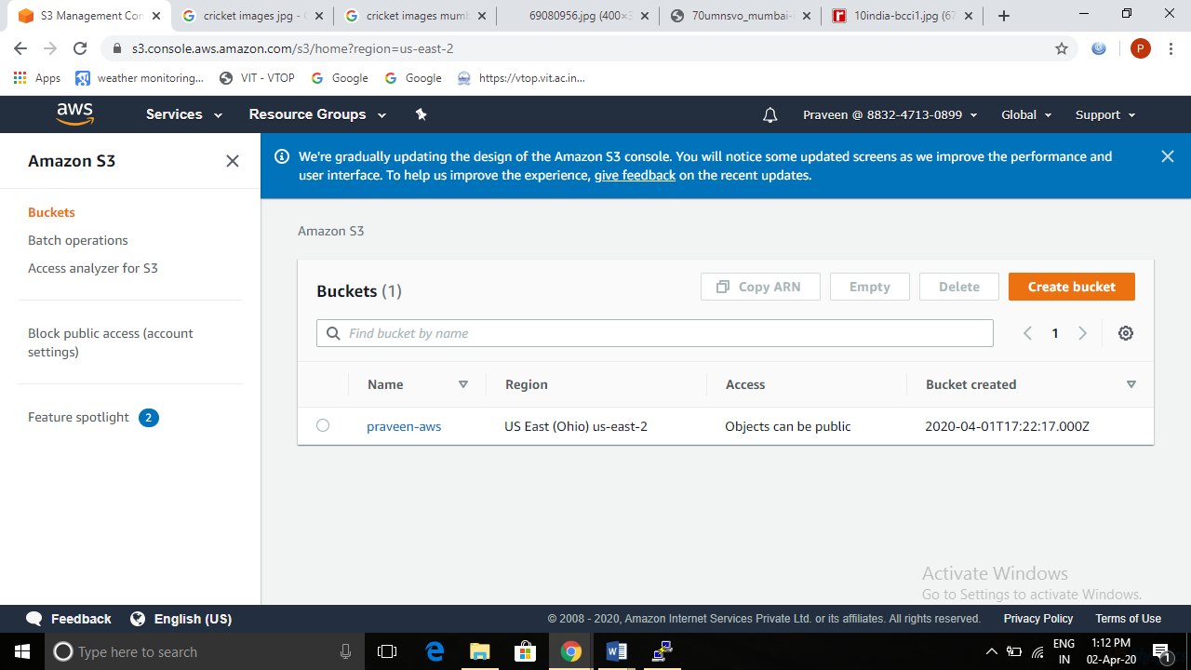

1. **Rekognition Dashboard**

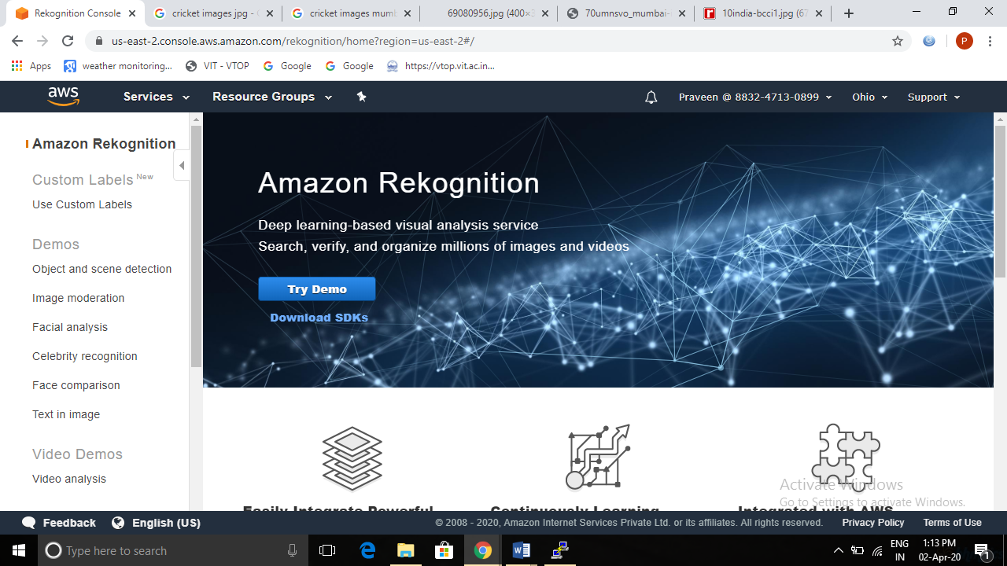

**Screenshots of EC2**

1. **Choosing an AMI**

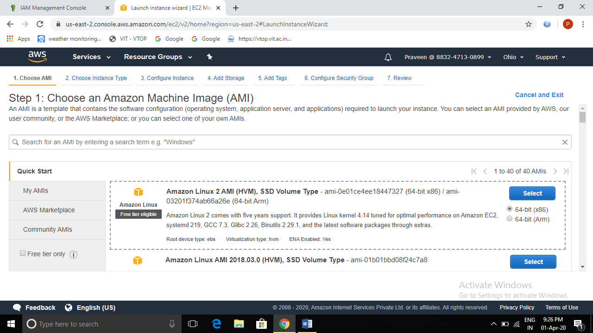

1. **Choosing an Instance Type**

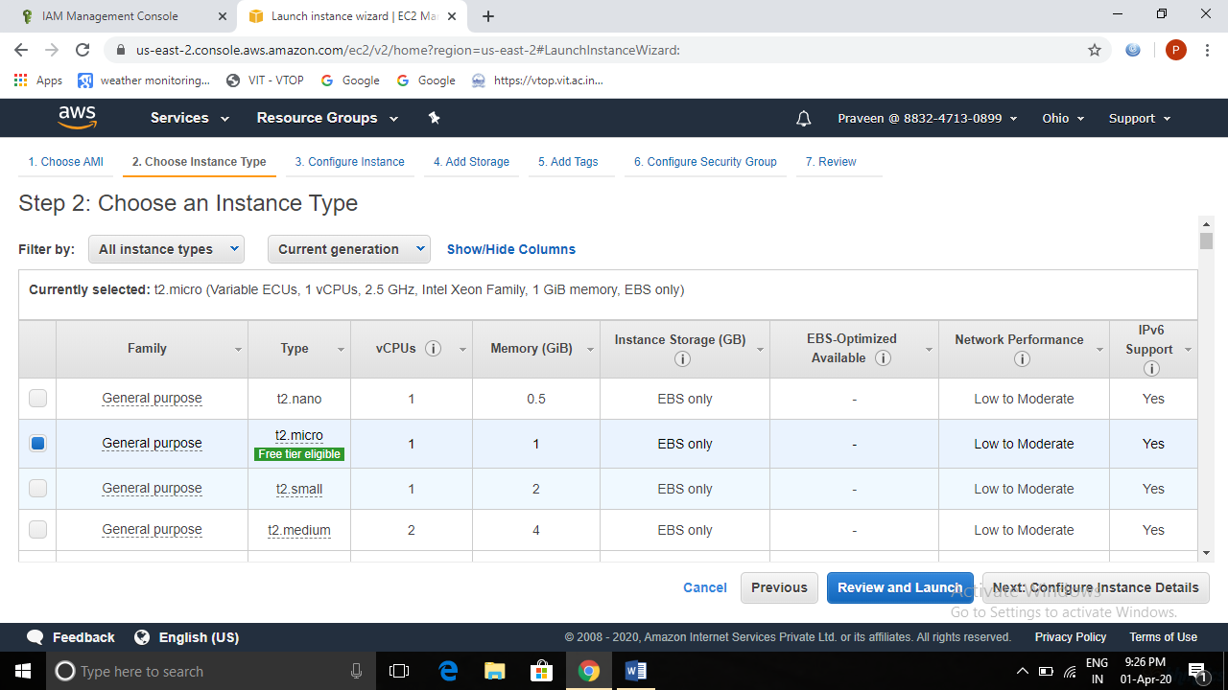

1. **Adding Storage**

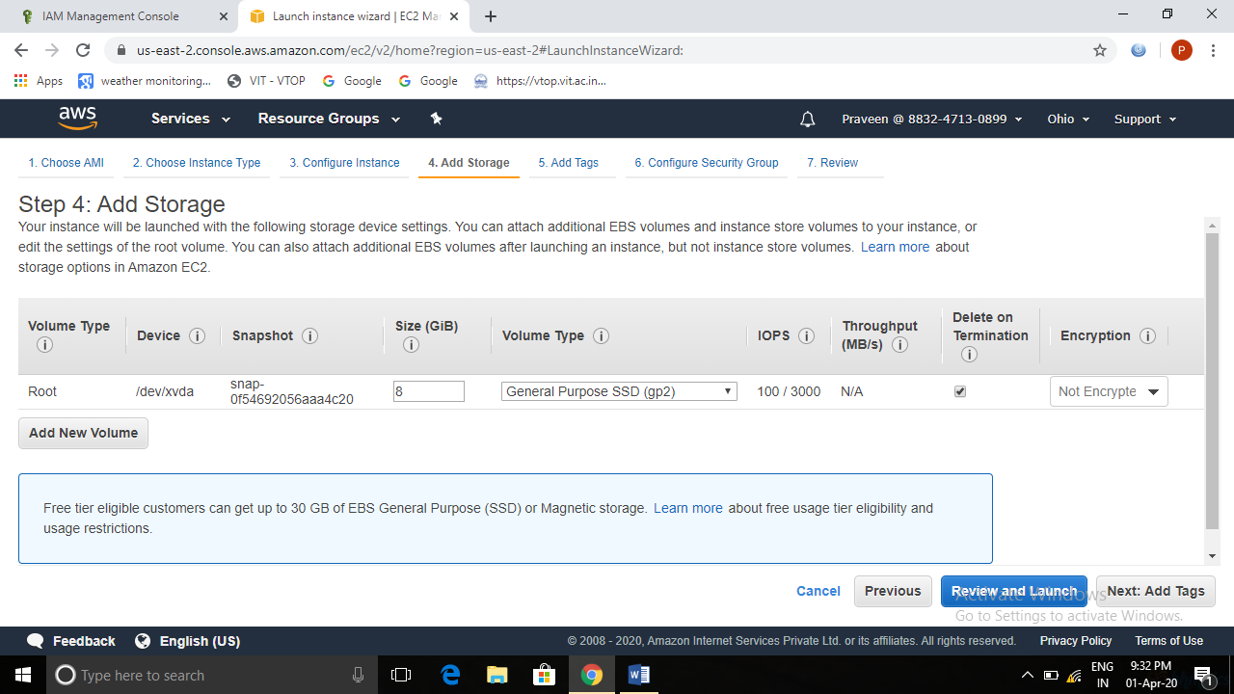

1. **Configuring Security Group**

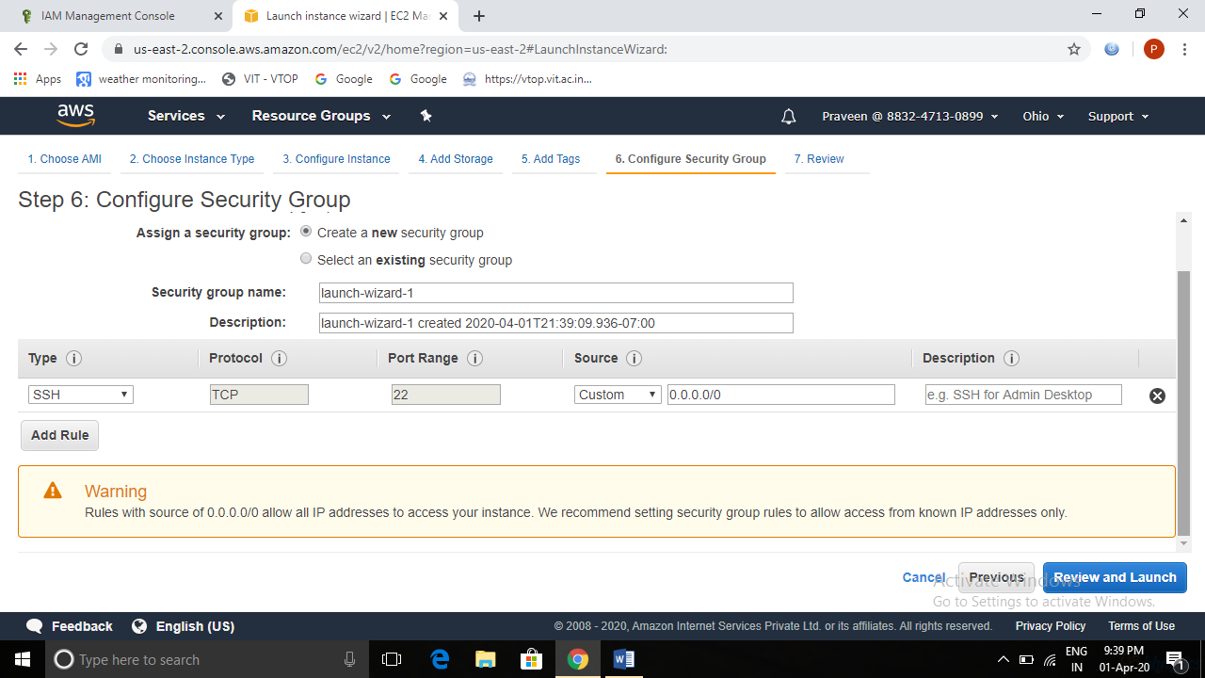

1. **Key Pair Download**

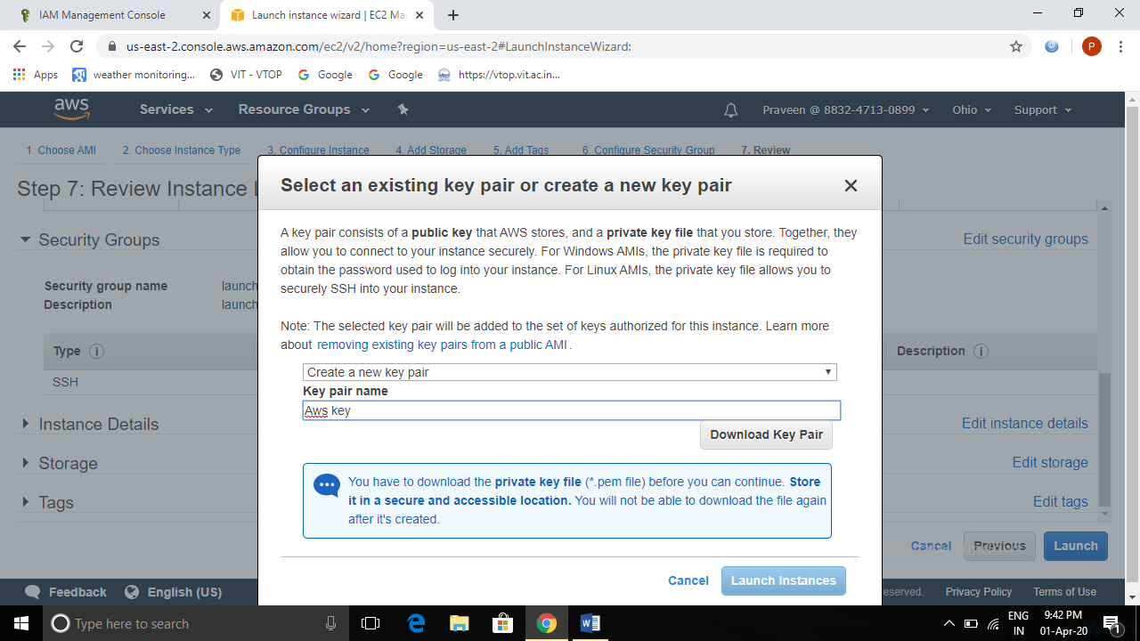

1. **PuTTYgen conversion from pem to ppk**

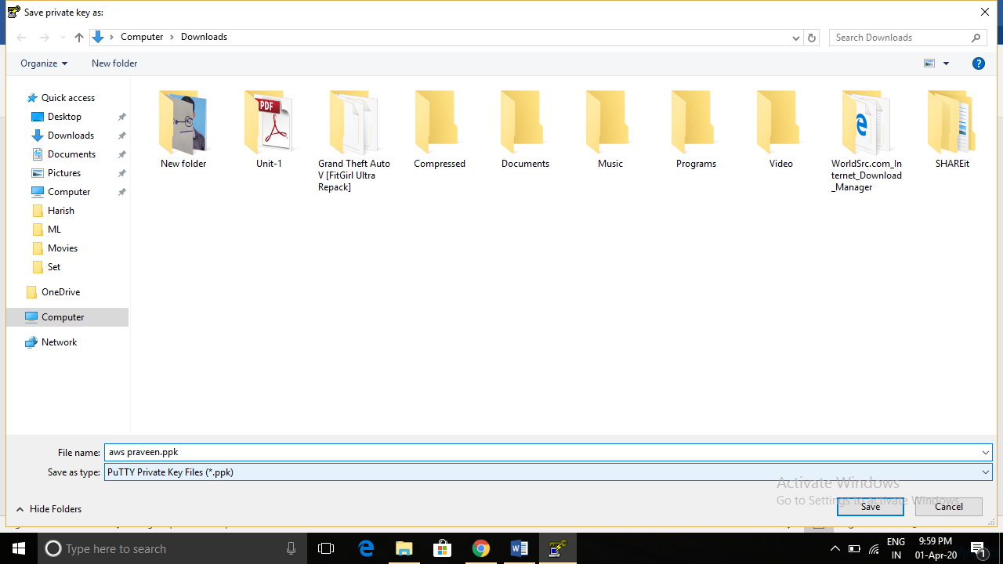

1. **Logged in EC2 black screen**

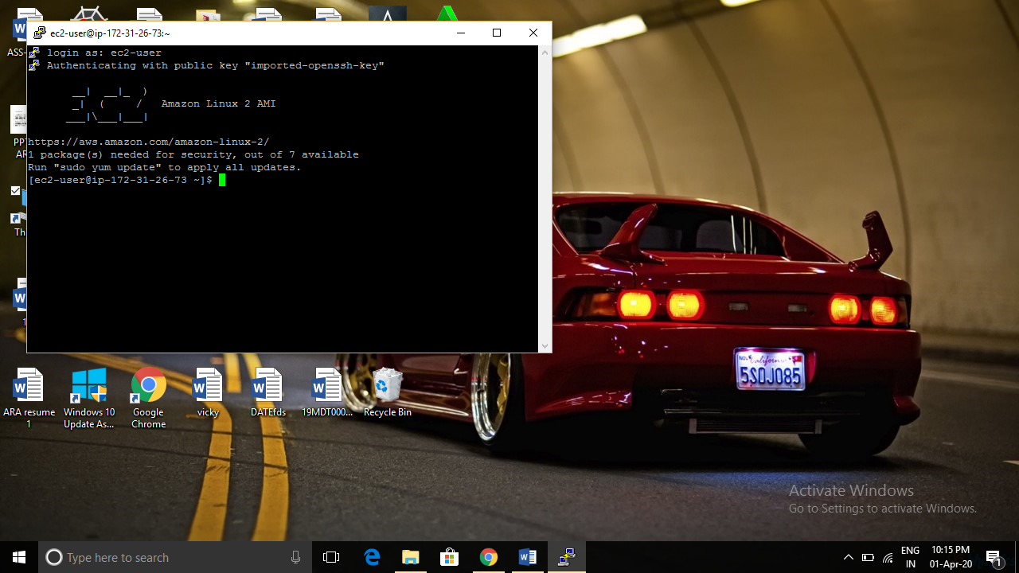

**Screenshots of S3**

1. **Creating a bucket**

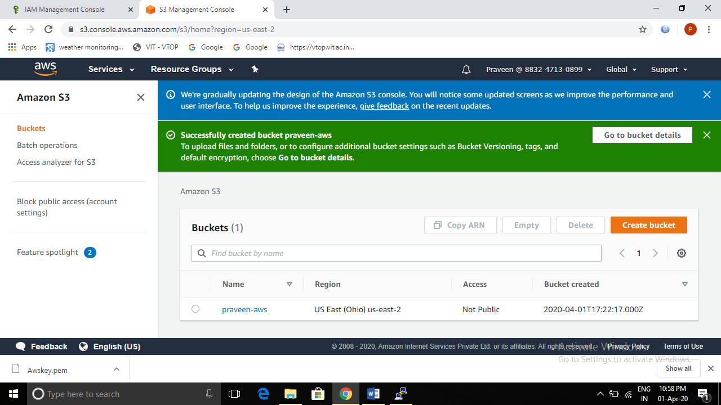

1. **Uploading an Object**

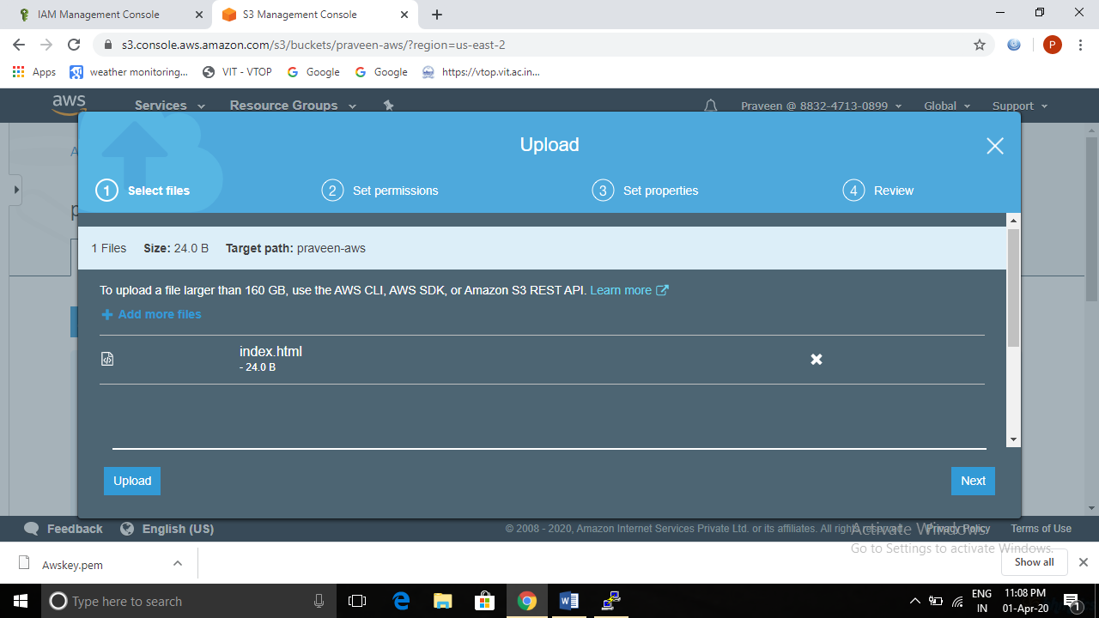

1. **Enabling Static Website**

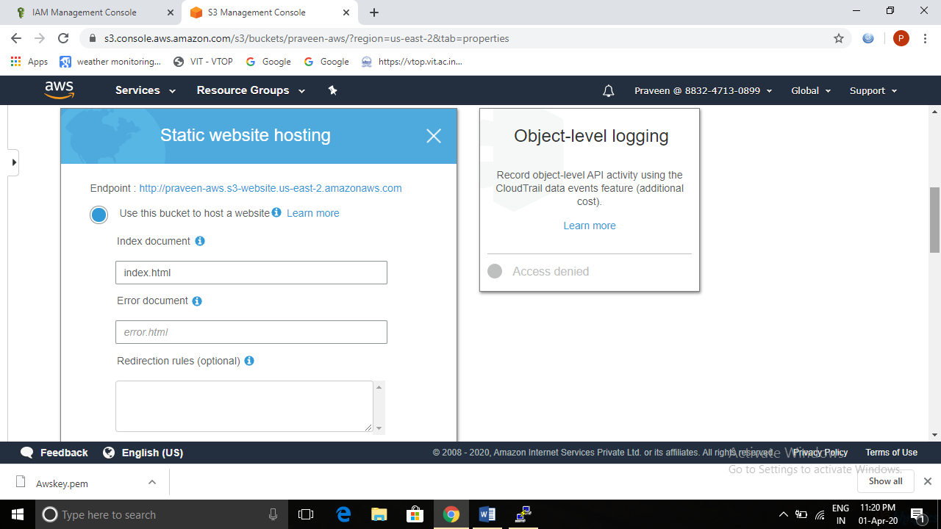

**4. Making the Object Public**

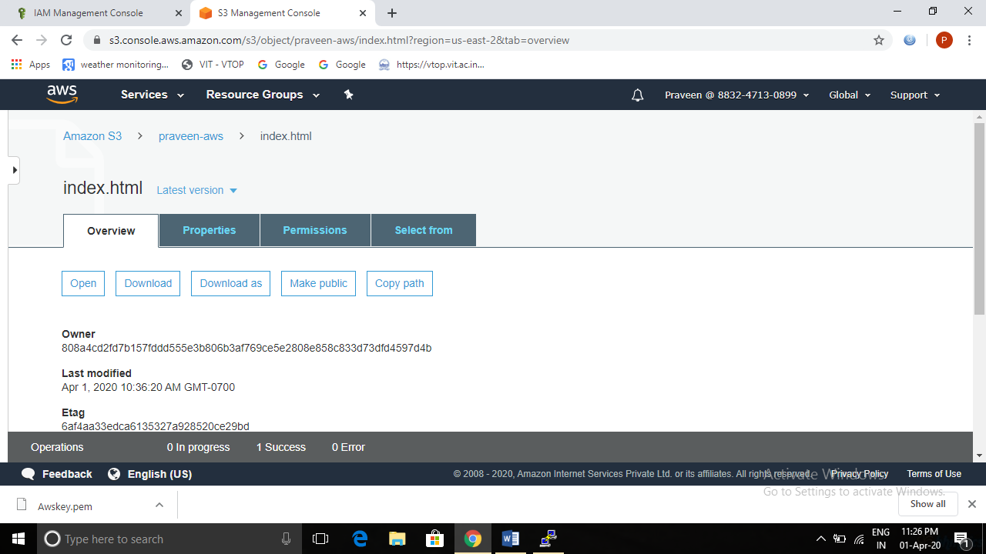

1. 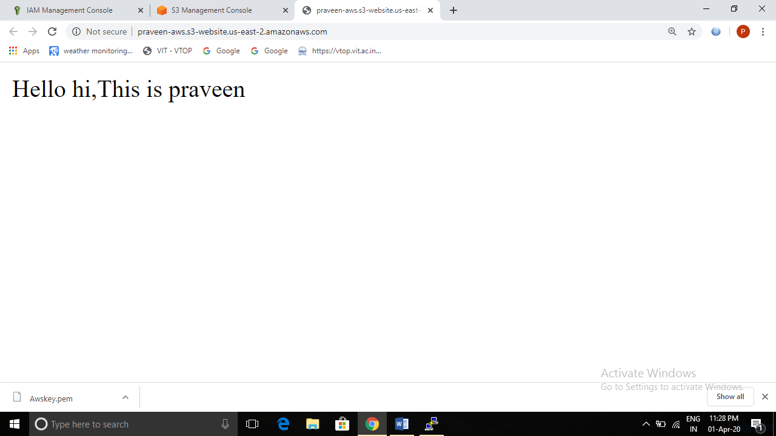**Checking the S3 link on the browser**

**Screenshots of Rekognition**

1. **Face Detect**

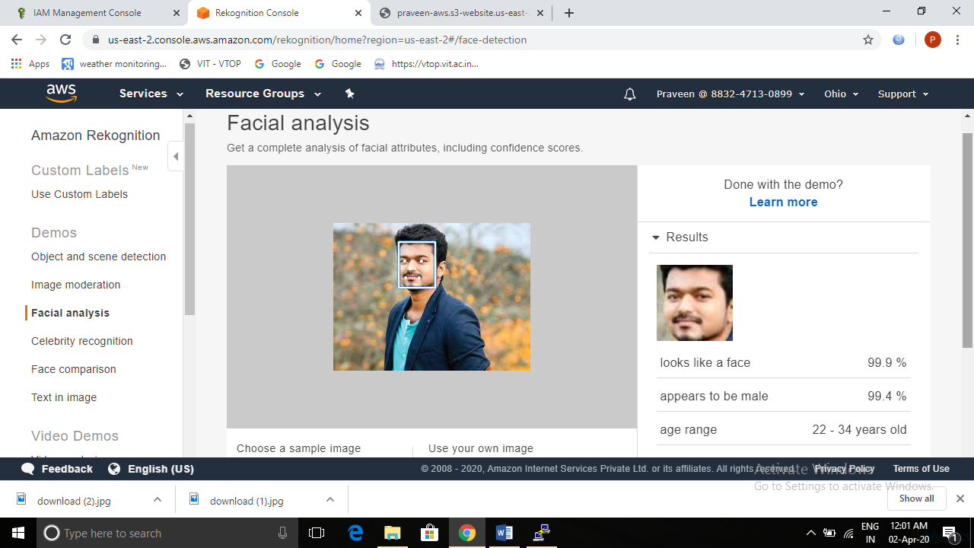

1. **Face Compare**

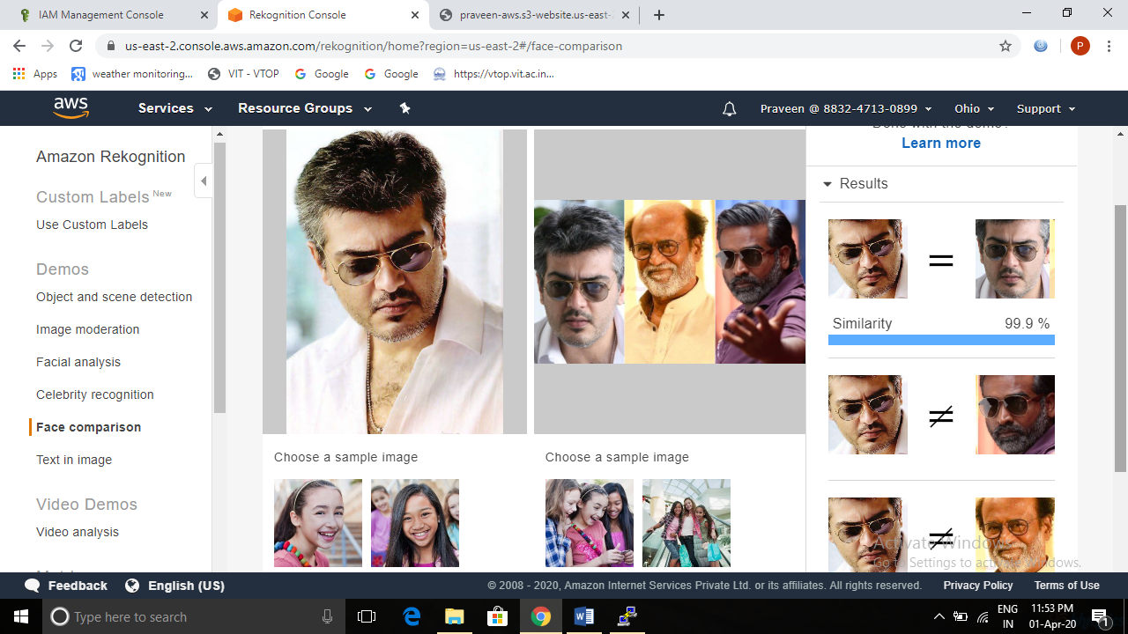

1. **Celebrity Recognition**

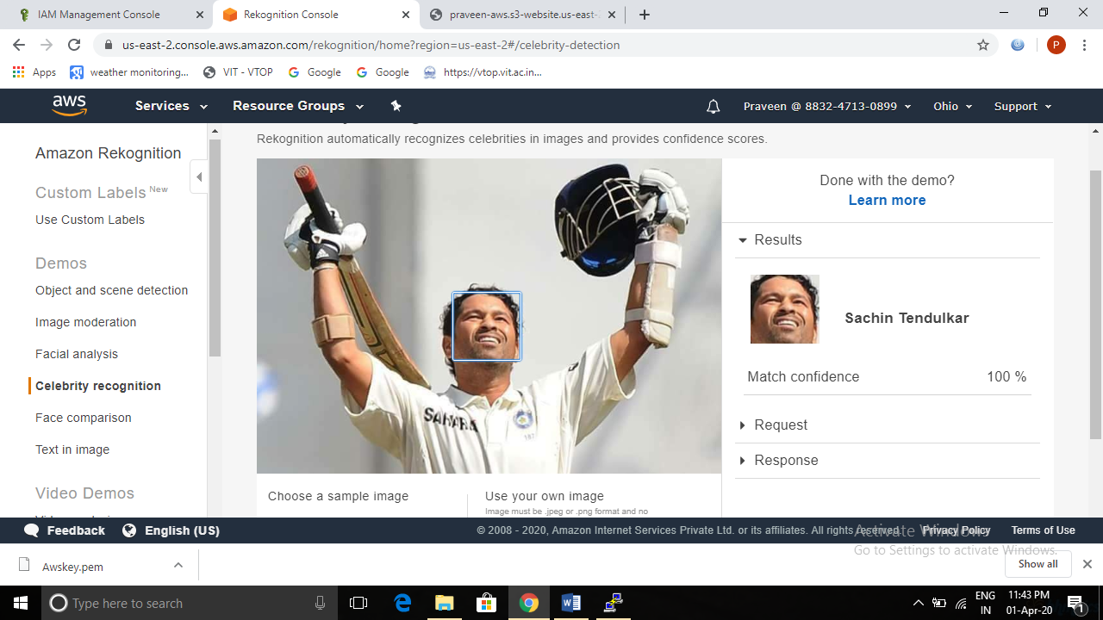

1. **Text in Image**

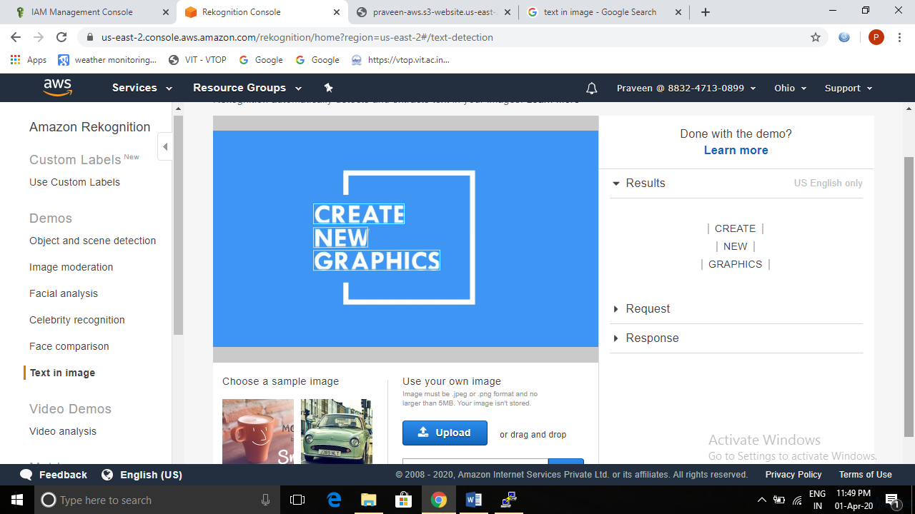

**Screenshots of EC2 & S3**

1. **Installing aws-sdk**

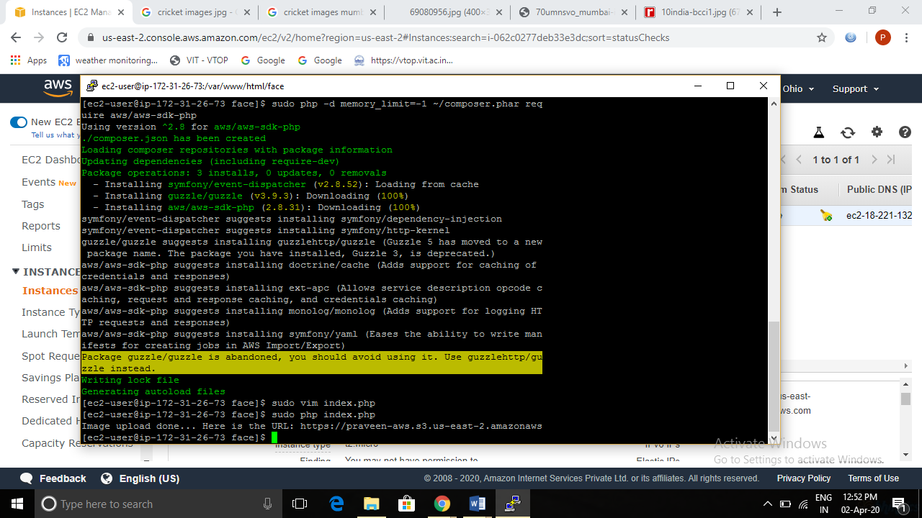

1. **Installing php**

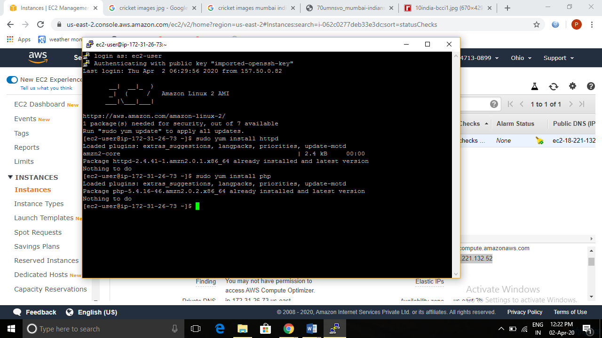

1. **index.php file code**

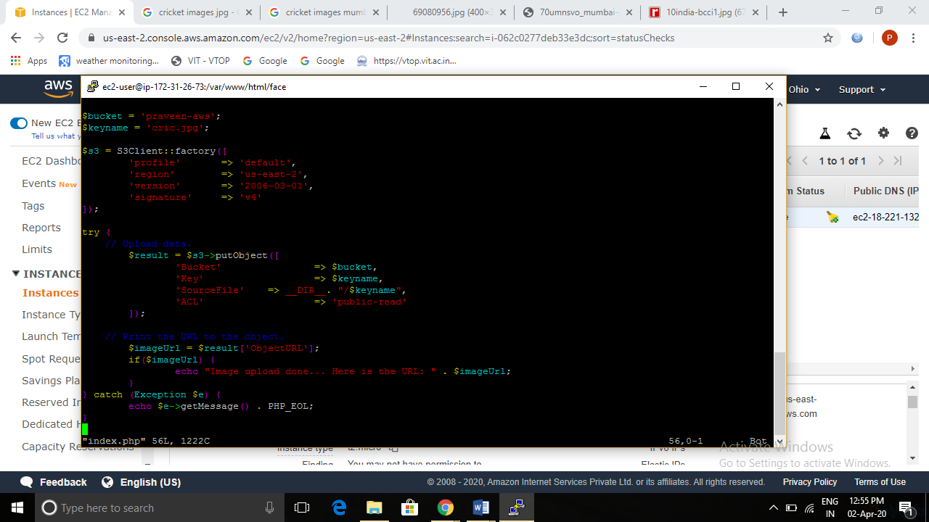

1. **Upload success screenshot**

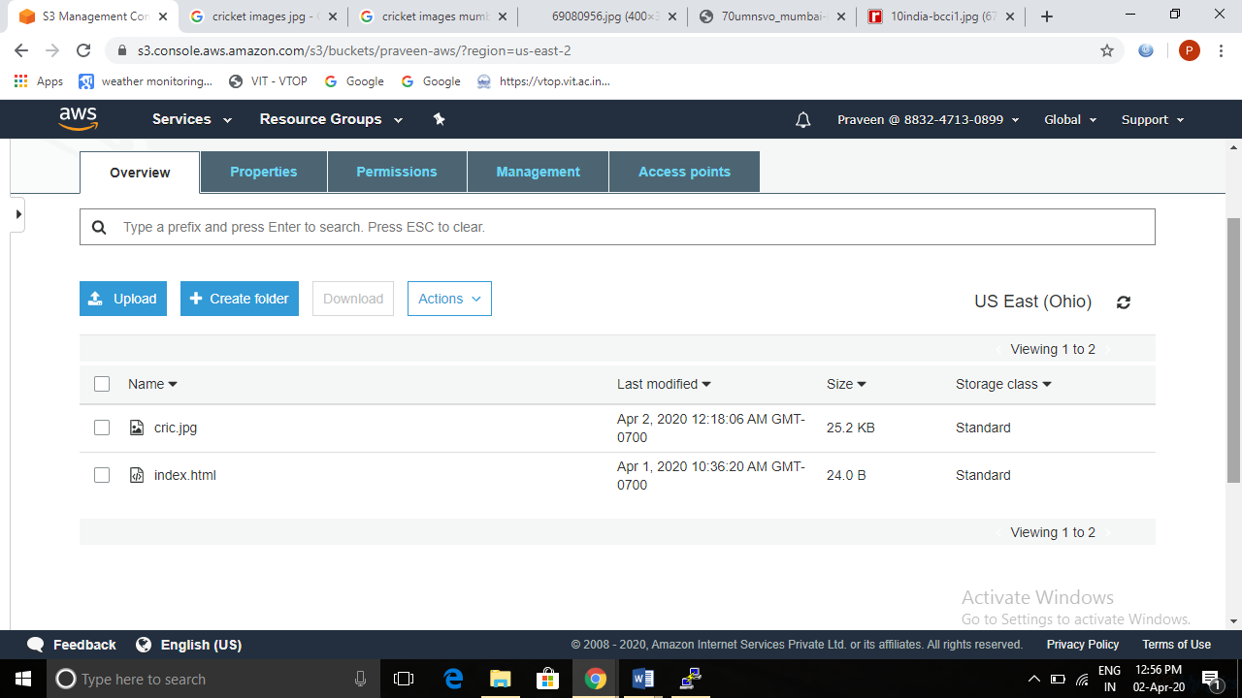

**Screenshots of EC2 & Rekognition**

1. **Face Detect success screenshot**

